UNIVERSITY OF ENGINEERING AND TECHNOLOGY

(NAROWAL CAMPUS)



# Object-Oriented Programming Lab Manual

Created by: Muhammad Abdullah

Registration Number: 2022-CS-525

Topics: 1-Dimension Array using Pointers,

2-D Array using Pointers, Dangling Pointer, Memory Leak,

and Recursive Function

Lab Manual

(Object-Oriented Programming Lab)

* **Task 1:**

Create a dynamic 1-Dimensional array using pointers in C++ program  
Program:

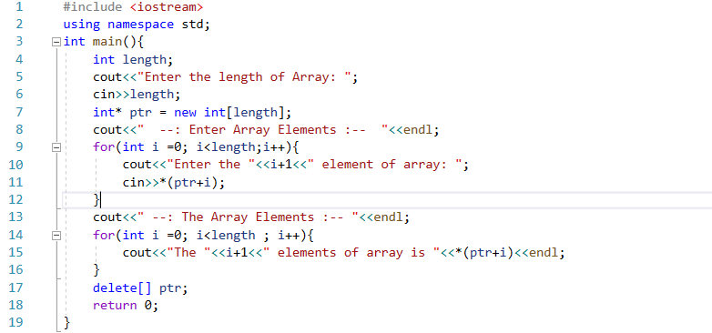

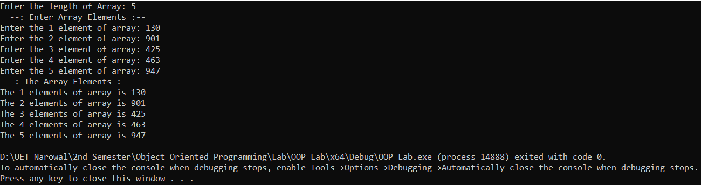Output:

* **Task 2:**

Create a 2-Dimensional array using pointers in C++ program

Program:

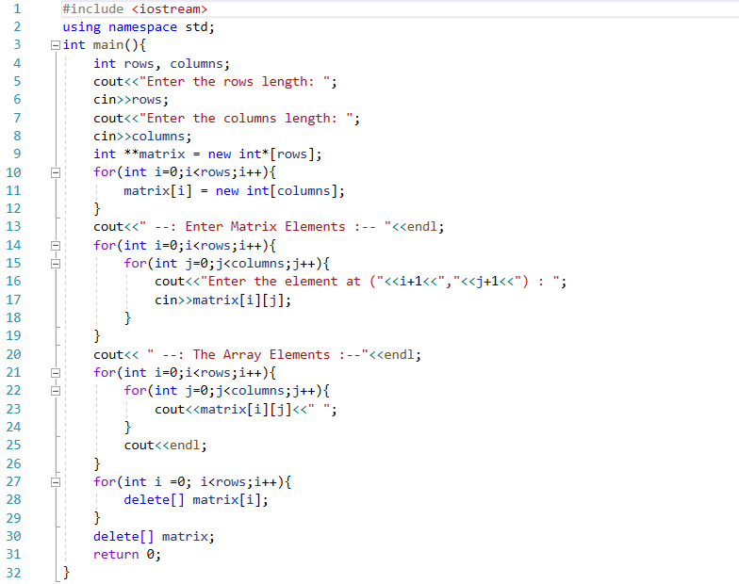

Output:

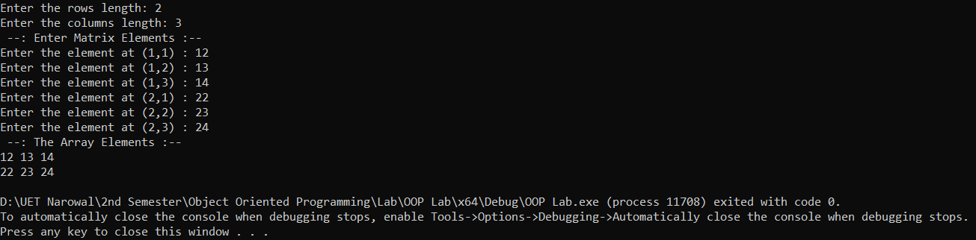

* **Task 3:**

Create a Dangling Pointer in C++ program:

Program:

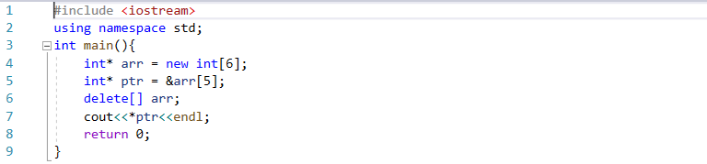

Output:

* **Task 4:**

Write a memory leak program in C++

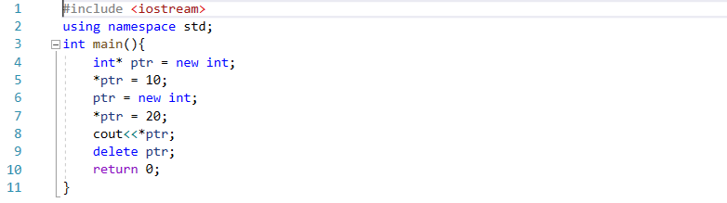Program:

Output:

* **Task 5:**

Create a function that reverses array elements using recursive approach in C++ program

Program:

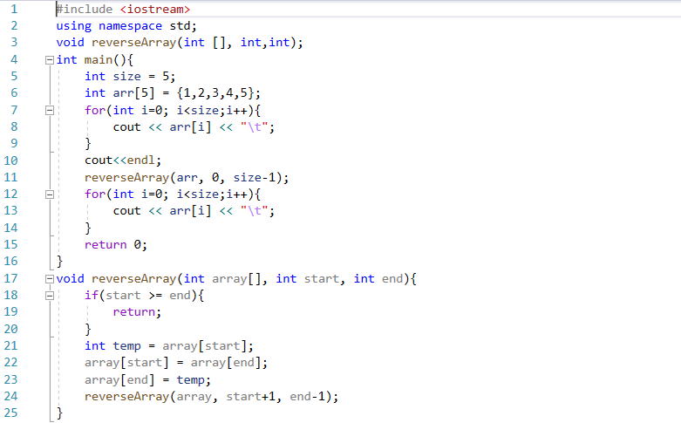

Output:

------------------------------------------------------------------------------------------------------------------------------------------